

**An Undergraduate Internship Report on**

**Fleet Management System**

By

**Sharar Nur Alvee**

Student ID: 1631152

**Spring, 2021**

Supervisor:

**Md. Abu Sayed**

Lecturer

Department of Computer Science & Engineering

Independent University, Bangladesh

**June 17, 2021**

**Dissertation submitted in partial fulfillment for the degree of Bachelor of Science in Computer Science**

**Department of Computer Science & Engineering**

**Independent University, Bangladesh**

Attestation

This is to certify that the report titled “Fleet Management System” was completed by Sharar Nur Alvee (ID-1631152) submitted in partial fulfillment of the requirement for the Degree of Computer Science from Independent University, Bangladesh (IUB). It has been completed under the guidance of Md. Abu Sayed (Internal Supervisor) and Md. Naimur Rahman (External Supervisor). I also certify that all my work is original and has not been submitted earlier to this university or any other institution. All the sources of information used in this Project Report has been duly acknowledged in it.

Signature Date

Sharar Nur Alvee

Acknowledgement

At the very beginning, I would like to thank the Almighty Allah for all His blessings which helped me to complete this report successfully.

I would also like to thank everyone who kindly provided me with information and gave me guidance for making this report. At first, I would like to thank **Department of Computer Science, Independent University, Bangladesh** for enlightening me over the period of my bachelor’s in computer science.

I would like to express my gratitude to my honorable supervisor **Md. Abu Sayed** from the core of my heart for his kind support, supervision, instructions, and advice for the completion of this report.

I am also thankful to the whole team of “**Mechanic koi Pvt. Ltd**” for giving me the opportunity to work with them in their IT department and providing me with the data and insights that were required for making this report. Also, I would like to thank **Md. Naimur Rahman**, Chief Technology Officer for guiding me all through the program.

Finally, I would like to thank all the faculties and mentors throughout my 4-year bachelor’s in computer science program at **Independent University, Bangladesh**. All these helped me to get a much better view about the present world and to overcome any challenge given to me.

Letter of Transmittal

June 17, 2021

Md. Abu Sayed

Lecturer

School of Computer Science and Engineering

Independent University Bangladesh

Subject: Submission of Internship Report

Dear Sir,

It is a great pleasure for me to present the internship report on “Fleet Management System” under the IT Department of **Mechanic koi Pvt. Ltd.** For the completion of my Bachelor of Computer Science Degree, I got this as my assignment. I am glad to inform you that, I have successfully completed my 12 weeks of Internship at **Mechanic koi Pvt. Ltd**, under the supervision of **Md. Naimur Rahman**, Chief Technology Officer. It was a great experience for me to work at **Mechanic koi Pvt. Ltd.** I am extremely grateful to you for your guidance and kind operation on this report. I would be grateful if you kindly go through my report and evaluate my performance.

I pray and hope this report will be quite interesting and fulfil your expectations. I have tried my best to avoid my deficiencies and hope that my report will satisfy you. I also would like to thank you again for giving me the opportunity to submit this report.

Sincerely,

Sharar Nur Alvee

ID- 1631152

Evaluation Committee

.....................................................................

Signature

.....................................................................

Name

.....................................................................

Supervisor

.....................................................................

Signature

.....................................................................

Name

.....................................................................

Internal Examiner

.....................................................................

Signature

.....................................................................

Name

.....................................................................

External Examiner

.....................................................................

Signature

.....................................................................

Name

.....................................................................

Convener

Abstract

Fleet Management System is a web application which aims to minimize the effort put in company to maintain their transactions. Fleet Management System has designed initially only for the usage of Admin. The web app is intended to do three major tasks i.e., vehicle management, mechanics management & work management. Vehicle management keeps track of all the vehicle related transactions. It includes New Vehicle Registration, Listing Vehicles, & Checking Availability.

Mechanics Management keeps track of all the mechanics, their necessary information, their working status, their workshop name & their availability.

While Work Management keeps track of all the active work, pending work, their deadline, total cost, and the work status. Tracking system will also be added very soon to keep track of your vehicle through Fleet Management System.

Contents

Attestation 2

Acknowledgement 3

Letter of Transmittal 4

Evaluation Committee 5

Abstract 7

Contents 8

List of Figures 11

List of Tables 12

List of Screenshots 13

Chapter 1 14

Introduction 14

1.1 Overview/Background of the Work 14

1.2 Objectives 15

1.3 Scopes 16

Chapter 2 17

Company Profile 17

2.1 Company Background 18

2.2 Vision and Mission 18

2.3 Product and Services 19

2.4 Company Departments 20

2.5 Contact and Address 20

Chapter 3 21

Literature Review 21

3.1 Relationship with Undergraduate Studies 21

3.2 Related works 23

Chapter 4 26

Project Management & Financing 26

4.1 Work Breakdown Structure 26

4.2 Process/Activity Wise Time Distribution 28

4.3 Gantt Chart 30

4.4 Process/Activity Wise Resource Allocation 31

4.5 Estimated Costing 33

Chapter 5 34

Methodology 34

Chapter 6 37

Body of the Project 37

6.1 Work Description 37

6.2 System Analysis 39

6.2.1 Six Element Analysis 39

6.2.2 Feasibility Analysis 41

6.2.3 Problem Solution Analysis 42

6.2.4 Effect and Constraints Analysis 44

6.3 System Design 45

6.3.1 Rich Picture 45

6.3.2 UML Diagrams 47

6.3.3 Functional Requirements 51

6.3.5 Non-functional Requirements 54

6.4 Product Features 55

6.4.1 Input 55

6.4.2 Input Stages 58

6.4.3 Output 60

6.4.4 Architecture 62

6.5 Implementation 63

6.5.1 phpMyAdmin 64

Chapter 7 66

Results & Analysis 66

Chapter 8 70

Project as Engineering Problem Analysis 70

8.1 Sustainability of the Project/Work 70

8.2 Social and Environmental Effects and Analysis 71

8.3 Addressing Ethics and Ethical Issues 73

Chapter 9 74

Lesson Learned 74

9.1 Problems Faced During this Period 74

9.2 Solution of those Problems 76

Chapter 10 78

Future Work & Conclusion 78

10.1 Future Works 78

10.2 Conclusion 79

Bibliography 80

List of Figures

Figure 4. 1 : Work Breakdown Structure 26

Figure 4. 2 : Activity Wise Time Distribution 28

Figure 4. 3 : Gantt Chart 30

Figure 5. 1 : Agile Methodology 35

Figure 6.3. 1: Rich Picture 41

Figure 6.3. 2 : Use Case Diagram 43

Figure 6.3. 3 : Activity Diagram 45

Figure 6.3. 4 : Fleet Management System Functions 47

Figure 6.4.4. 1 : Three Tier Architecture 57

List of Tables

Table 4.4. 1 : Activity wise Resource & Time Allocation Table 33

Table 4.5. 1 : Estimated Costing 34

Table 6.2. 1 : Six Element Analysis 37

Table 6.5.1. 1 : Login 66

Table 6.5.1. 2 : Vehicle List 66

Table 6.5.1. 3 : Mechanic List 67

Table 6.5.1. 4 : Work Order List 67

Table 7. 1 : Result & Analysis 63

List of Screenshots

Screenshot 6.4.1. 1 : Login Page 56

Screenshot 6.4.1. 2 : Add Vehicle Form 57

Screenshot 6.4.1. 3 : Add Mechanic Form 57

Screenshot 6.4.1. 4 : Add Work Order 58

Screenshot 6.4.3. 1 : Dashboard 61

Screenshot 6.4.3. 2 : All Vehicle 61

Screenshot 6.4.3. 3 : All Mechanics 62

Screenshot 6.4.3. 4 : All Work Order 62

Chapter 1

Introduction

1.1 Overview/Background of the Work

Fleet management is the process your business uses to manage all fleet and asset information, from acquisition through to disposal. This enables your business to reduce costs, improve efficiency and ensure compliance across an entire fleet operation. We know that managing a pool of commercial vehicles can be a challenge at the best of times. Add to these external influences that a fleet manager faces but has little control over, such as legislation, car market uncertainty and spiraling costs, and the task can soon become overwhelming. In our view, the relevant software can play an enormous part in coordinating your fleet management activities.

Fleet Management System is the management of a transportation fleet. It is a web application which aims to minimize the effort put in company to maintain their transactions. It can keep a track of your drivers, manages all the transactions related to Vehicle profiling and the issues that can arise with your vehicles. It is a function which allows removing or minimizing the risks associated with vehicle investment, improving efficiency, productivity and reducing their overall transportation and staff costs. These functionalities can be incorporated either as in-house fleet-management department or through an outsourced fleet-management provider.

The application is designed only for the usage of admin. Only Admin can use the software only after they are registered to the system. They can retrieve their Password if they have forgot using their email id. Fleet management is system built of different segments:

* Vehicles
* Mechanics
* Tracking
* Work Order
* Dashboard

1.2 Objectives

Project objectives are what you plan to achieve by the end of your project. This might include deliverables and assets, or more intangible objectives like increasing productivity or motivation. Your project objectives should be attainable, time-bound, specific goals you can measure at the end of your project. Project objectives are a critical element of [project management](https://asana.com/resources/benefits-project-management)—without them, you don’t have a succinct way to communicate your goals before and during the project, nor do you have a measurable way to evaluate your success after the project ends.

The objectives list defines the specific goals for a web application to accomplish. Based on the purpose statement and audience definition of the web, you can list the specific information, communication, or activity your web will support. Here I am giving the objectives of my web application fleet management system:

1. The aim of this application is to reduce the manual effort needed to manage transactions in a company.
2. Application provides an interface to admin to view the details like the Vehicle & the drivers information, Profile Management, Repair and Maintenance schedules and all the other transactions related to Vehicle profiling.
3. Increases the profitability of the company by reducing the cost to purchase different software for different tasks to be performed.

1.3 Scopes

Project scope is a detailed outline of all aspects of a project, including all related activities, resources, timelines, and deliverables, as well as the project’s boundaries. A project scope also outlines key stakeholders, processes, assumptions, and constraints, as well as what the project is about, what is included, and what is not. All of this essential information is documented in a scope statement. Some of the scopes of fleet management system are:

* To register and keep the information about all vehicles.
* To build up a system that provides and generates the summary.
* Report from the database records in order to get the whole view about the vehicles amounts.
* Summarize the accidental records and responds for the further improvements.
* A web-based application where user can search for additional information of the vehicle.

Chapter 2

Company Profile

2.1 Company Background

**Your Reliable Vehicle Facility Manager**

“Mechanic koi” is an online platform that provides 360-degree vehicle solutions. Vehicle parts and accessories are also available through the e-commerce platform of Mechanic koi. It is one of the leading Automotive startups in Bangladesh which is working since 2017.

* We make auto repair more convenient for you.
* We get the job done right — the first time.
* Proven Results for Setting Exceptional Standards
* Same day service for most repairs

2.2 Vision and Mission

**We are Qualified & Professional.**

The main mission of the company is to provide honest, friendly, and on-time service. A locally owned and operated business that has been serving the community since 2018.

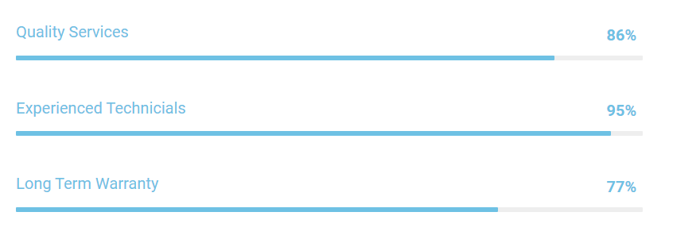

2.3 Product and Services

A Wonderful serenity taken possession into entire soul as like these sweet mornings of spring which thing of existence in this spot, which was the main part created for the bliss often soul like mine. I am so happy, my dear friend does sorbed in the exquisite.

* We handle all makes and models in more than 40 car brands.
* We are endorsed by the local trading standards office.
* All our technicians are equipped with the latest portable technology.

**Our Services:**

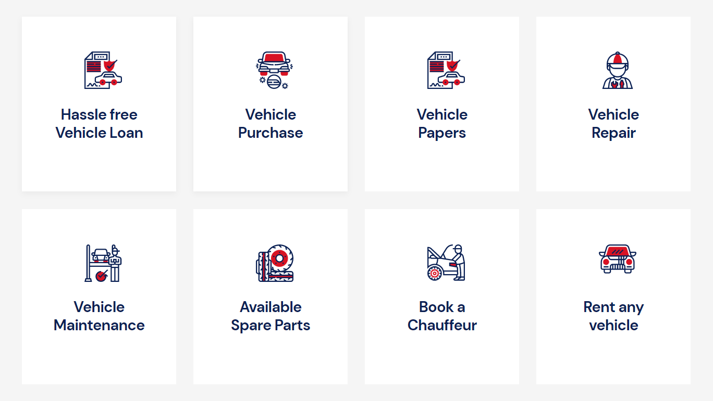

2.4 Company Departments

The company maintains a flat organizational structure. Teams and responsibilities are generally formed and assigned around specific projects.

2.5 Contact and Address

Address: BCC Bhaban, CWS, Startup Bangladesh, ICT Tower, Plot-E 14/X, Dhaka, 1207  
Phone: +8801317331514  
Email: [mechanic.koi.bd@gmail.com](mailto:mechanic.koi.bd@gmail.com)

Website: [www.mechanickoi.com](http://www.mechanickoi.com@gmail.com)

Chapter 3

Literature Review

3.1 Relationship with Undergraduate Studies

This project is related to my undergraduate studies as I am from Computer Science and Engineering Department, I had learned coding of making various application. Some of the course where I can relate.

In CSE-303 Database Management course, I got introduced with detailed coverage of the development process, database architectural principles, relational algebra and SQL using XAMPP Server. Other key database topics which I have learned are data modelling, database security, administration, and distributed systems. I worked with Data analysis and reporting system of University Grant Commission Bangladesh (UGC**)** for the course project where I have been working with HTML, CSS, JavaScript & PHP as Programming &Markup language, and MySQL as database. In my internship project I have also working with the Xampp server to create the website application. So, during my internship work this course help me a lot to complete my project.

In CSE 309 Web Applications and Internet course, I got introduced to HTML, CSS, and JavaScript language. I worked with Online quiz system for the course project where I used HTML, CSS, and JavaScript as front-end and PHP & MySQL as backend. Since I have been working with same technologies to create a website application for my Internship Project. For this reason, this course has been of great help. In the meantime, I got acknowledged about GitHub from this course that I had to use this in my Internship Program as well.

CSE 307: System Analysis and Designcourse examines the tools and techniques used for the design and analysis of information systems. In this course I learned Systems and models, Project management, Tools for determining system requirements, data flow diagrams, decision table and decision trees, Systems analysis, System design and implementation, Front-end and backend design; database design; software management and hardware selection and so many things which gives me the proper direction of completing my internship project.

3.2 Related works

For completion, justification and solving the problem definition, a number of research papers, magazines, journals, and online links are investigated in detail.

In this part, the details of research papers and journals are specified from where we have analyzed the content and formulated the problem.

A number of research scholars and scientists has written a number of research papers and found excellent results. This section underlines all those research papers and their extracts.

Jung, Jayakrishnan, and Park proposed Design and Modeling of Real-time Shared-Taxi Dispatch Algorithms. In this paper, an optimization scheme is developed for the real-time vehicle routing in fully flexible shared-taxi systems and a simulation study is conducted to investigate how such a shared-taxi system can improve passenger travel compared to conventional taxi services by utilizing vehicle resources more efficiently. Real-time shared-taxi operation with associated algorithms is studied with realistic scenarios, to evaluate the system performance and the efficiency of solving the vehicle routing problem [1].

Three different algorithms for shared taxi are introduced and compared.

1. A Nearest Vehicle Dispatch (NVD) algorithm that is most commonly used in real Applications.
2. An Insertion heuristic (IS) that handles real-time passenger requests in a fast and simple manner.
3. A Hybrid Simulated Annealing (HSA) that assign passengers efficiently and dynamically to available vehicles.

Anurag Mandle, Akshay Jaiswal, Bhushan Dod, Roshan Lokhande focused on Taxi Automation Using Real Time Adaptive Scheduling. In TAS (Taxi Automation System), online dispatch of available taxis to current customer bookings is done with the aid of a satellite-based taxi automation system; the system utilizes a Global Positioning System (GPS) to automatically locate taxis in real-time. In handling current taxi online bookings, the major focus of taxi automation systems has been primarily on reaching individual customers in the shortest time possible to enhance customer satisfaction [2].

Proposed solution has an automated adaptive scheduling subsystem and shortest path algorithm which has the ability to match drivers and orders and to change their statuses automatically. While selecting the taxi during the allotment the different microeconomic data that is considered includes the following

* The current status of the taxi.
* The remaining distance of the journey of the already allocated taxi.
* Distance from the destination to the source i.e., from where the new request is generated.

Michael Berman, Sue M. Lewis and Anthony Conto focused on Location-Aware Computing. Proposed System that can sense the current location of a user or device and change behavior based on this location, such as GPS. Since a GPS device knows its current location, it can give directions to the GPS user for how to get to a new location and it can update these directions continuously as the device moves [3].

Practical concerns related to location-based services are accuracy of location information, visualization, timeliness of the information, and transparency of location information. Privacy concerns must be a part of the design for location-based services. Users must be aware of when they can be uniquely identified, who has access to their location data, and how long this data may persist.

Suhas Holla and Mahima M Katti focused on ANDROID BASED MOBILE APPLICATION DEVELOPMENT and its SECURITY. Android Mobile Application Development can be used to create innovative and dynamic third-party applications. Mobile Development India has worked extensively on projects ranging from gaming software, organizers, media players, picture editors to go-cart devices and more. SQLite is embedded into android which supports relational database [4].

Detection algorithms can be deployed in the cloud, providing a fast and distributed detection of suspicious software in a mobile software store skin to Google’s Android Market. The ultimate goal is to protect the mobile applications from the malicious attributes and safeguard the interests of Android mobile users.

Chapter 4

Project Management & Financing

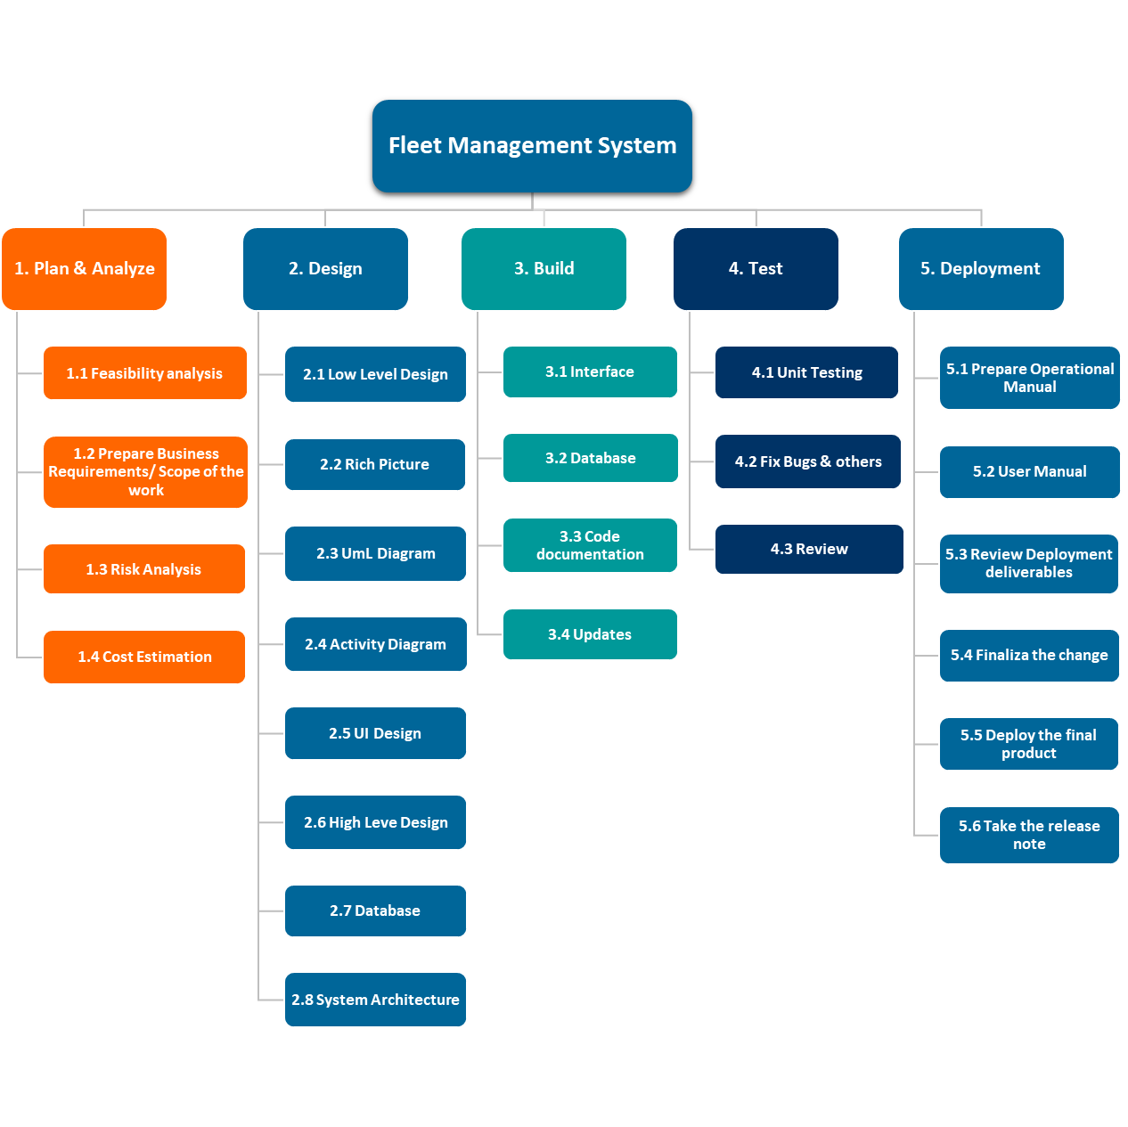4.1 Work Breakdown Structure

Figure 4. 1 : Work Breakdown Structure

Breaking work into smaller tasks is a common productivity technique used to make the work more manageable and approachable. For projects, the Work Breakdown Structure (WBS) is the tool that utilizes this technique and is one of the most important project management documents. It singlehandedly integrates scope, cost and schedule baselines ensuring that project plans are in alignment.

In the above work breakdown structure at the top is our final deliverable which is fleet management system. Immediately beneath that is the next stage of deliverables, which are the main tasks required to complete the project.

Each of those five project phases—plan & analyze, design, build, test, and deployment—branch off the main deliverable at the top. Once decided, they are then broken down into a series of tasks. For example, the plan & analyze phase includes feasibility analysis, create business requirement, risk analysis and cost estimation.

The WBS, when created as thoroughly as possible, is the roadmap to guide you to completion of what would seem to be a very complicated project. However, when broken down with a WBS, the project suddenly becomes much more manageable.

4.2 Process/Activity Wise Time Distribution

The critical path method (CPM), also known as critical path analysis (CPA), is a scheduling procedure that uses a network diagram to depict a project and the sequences of tasks required to complete it, which are known as paths. Once the paths are defined, the duration of each path is calculated by an algorithm to identify the critical path, which determines the total duration of the project. It is the sequence of activities with the longest duration. A delay in any of these activities will result in a delay for the whole project. Below is the critical path of fleet management system which helps to understand the key elements...

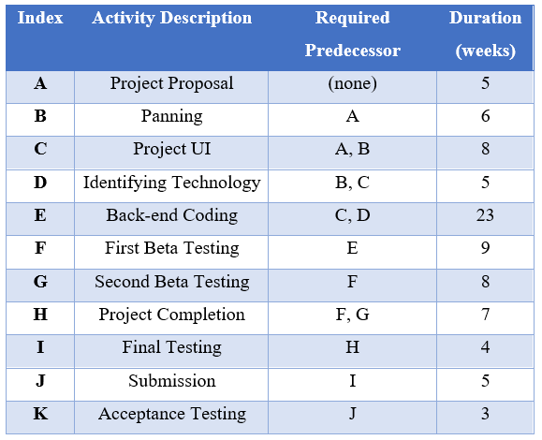

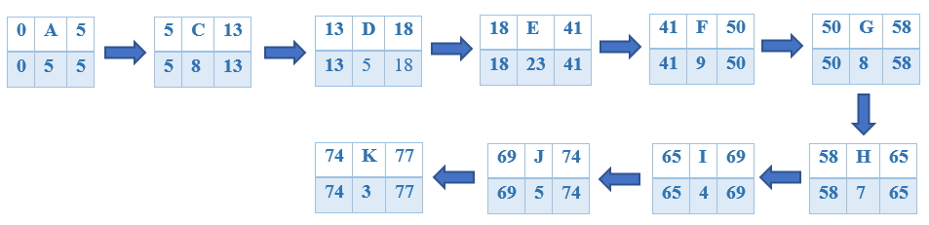

Figure 4. 2 : Activity Wise Time Distribution

The duration of each activity is listed above each node in the diagram. For each path, add the duration of each node to determine its total duration. The critical path is the one with the longest duration.

4.3 Gantt Chart

A Gantt chart is a graphical depiction of a project schedule. It is a type of bar chart that shows the start and finish dates of several elements of a project that include resources, milestones, tasks, and dependencies. Henry Gantt, an American mechanical engineer, designed the Gantt chart.

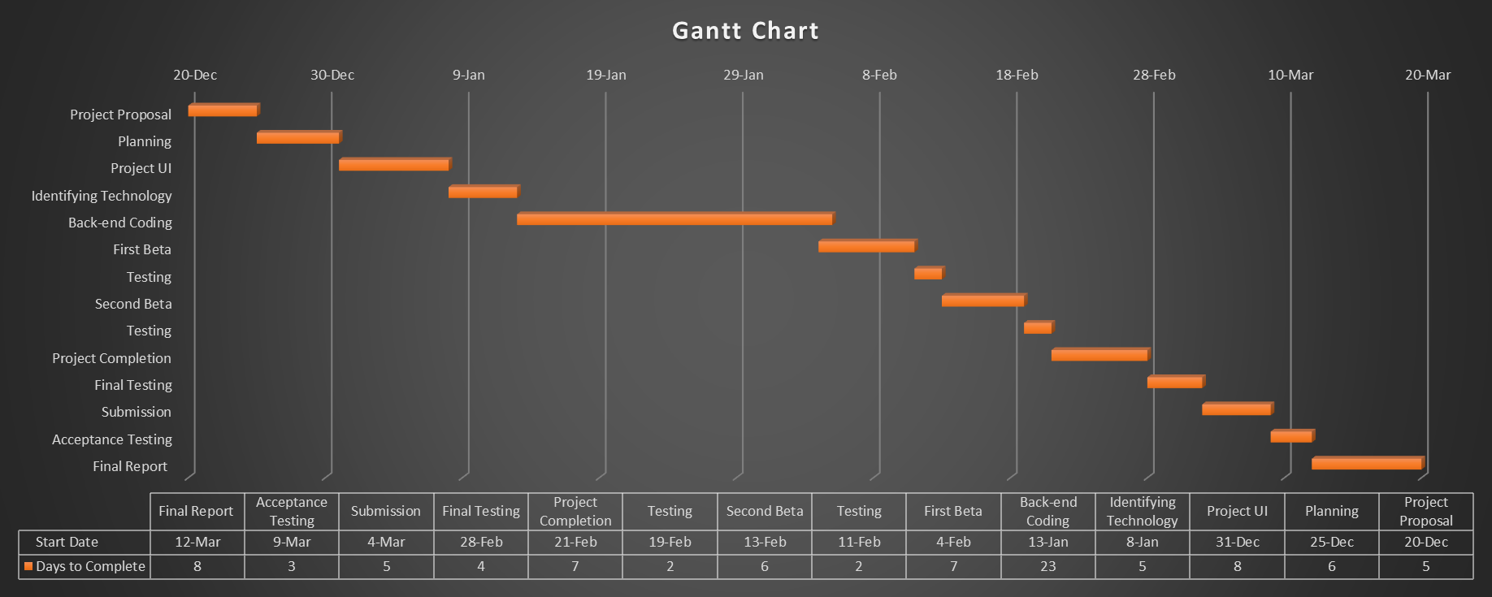

Figure 4. 3 : Gantt Chart

Gantt chart is a horizontal bar chart showing the start and end dates of each task within a project.  Here in the Gantt Chart, I am showing all the tasks that I have done in the project on the vertical axis such as project proposal, planning, project ui, identifying technology etc. and the time duration on the horizontal axis such as 20 December to 30 December, 30 December to 9 January etc.  The tasks are shown sequentially.  It can have many other pieces, but these are the basic building blocks.

4.4 Process/Activity Wise Resource Allocation

1. **Requirement Analysis:** Requirements Analysis is the process of defining the expectations of the users for an application that is to be built or modified. It involves all the tasks that are conducted to identify the needs of different stakeholders. Therefore, requirements analysis means to analyze, document, validate and manage software or system requirements. In fleet management system requirement analysis takes around 10 days and considered 10% of the total work.
2. **Design Layout:** Graphic design layout refers to the way in which we arrange the elements on a page which makes up the content of a design. The aim of layout is both to convey the message correctly and to present information in a logical, coherent way making the important elements stand out. For the graphic design layout of fleet management system, we used Adobe XD which is a vector-based user experience design tool for web apps and mobile apps. This takes around 10 days and considered 20% of the total work.
3. **Development:** A software development process is the process of dividing [software development](https://en.wikipedia.org/wiki/Software_development) work into smaller, parallel or sequential steps or subprocesses to improve [design](https://en.wikipedia.org/wiki/Software_design), [product management](https://en.wikipedia.org/wiki/Software_product_management), and [project management](https://en.wikipedia.org/wiki/Software_project_management). It is also known as a software development life cycle (SDLC). The methodology may include the pre-definition of specific [deliverables](https://en.wikipedia.org/wiki/Deliverable) and artifacts that are created and completed by a project team to develop or maintain an application. This is one of the major phases of fleet management system which takes around 25 days to complete and considered 47% almost half of the total work.
4. **User Acceptance Testing (UAT):** User Acceptance Testing (UAT) is a type of testing performed by the end user or the client to verify/accept the software system before moving the software application to the production environment. UAT is done in the final phase of testing after functional, integration and system testing are done. Quality assurance is also taken care in this phase. This takes around 10 days and considered 18% of the total work.
5. **Deployment:** Finally, after the approval from the client, the project is hosted on the client’s domain and hosting and the FMS is handed over to the clients and necessary training is provided to the client. This takes around 5 days and considered 5% of the total work.

|  |  |  |
| --- | --- | --- |
| Task | Days | Work Percentage |
| Requirement Analysis | 10 | 10% |
| Design Layout | 10 | 20% |
| Development | 25 | 47% |
| User Acceptance Testing (UAT) | 10 | 18% |
| Deployment | 5 | 5% |
| Total | 60 | 100% |

Table 4.4. 1 : Activity wise Resource & Time Allocation Table

4.5 Estimated Costing

Cost estimation is the process of estimating all of the costs associated with completing a website within scope and according to its timeline. It depends on the size, requirements, functionalities, and design of the website. This includes pre-designed themes, logo design cost, the cost for home page sliders, search-engine optimization and many other tools that were used to build this website. The cost of developer and resources used were also taken into note. The approximate cost estimated is Tk. 1, 50,000. If service support is required after 1 year of deployment, then an additional charge will be taken for hosting and domain.

|  |  |  |
| --- | --- | --- |
| Stage | Time | Price |
| UI/UX design | 15-80h | 30,000 BDT |
| Front end | 20-250h | 40,000 BDT |
| Back end | 80-250h | 60,000 BDT |
| Admin panel | 60-180h | 20,000 BDT |
| Total | 175-760h | 1,50,000 BDT |

Table 4.5. 1 : Estimated Costing

Chapter 5

Methodology

The Agile methodology is a way to manage a project by breaking it up into several phases. It involves constant collaboration with stakeholders and continuous improvement at every stage. Once the work begins, teams’ cycle through a process of planning, executing, and evaluating. Continuous collaboration is vital, both with team members and project stakeholders.Diagram
In this project I have used the agile methodology for our development.

Figure 5. 1 : Agile Methodology

I have adapted this for several reasons:

* It has a lower cost, as there is always a scope for correction and changing the implementation and carry out something better as the project grows.
* It enables our clients to take part in the development process and voice what they require from our program and taking their feedback into consideration to make the end product better.
* It enables us to openly communicate with the clients, take their suggestions and visions, and also show them what other alternatives we have and how we can make it better by discussing amongst ourselves.
* Debugging and testing becomes easier as we are constantly checking for defects and errors and fixing them as we go, and not at the complete end of the project. Thus, making us more competitive in the market and other developers as well.
* Evaluating and preparation time is speed up greatly as each iteration consists of a small section of the entire project, so we can finish it and then focus on the next rather than the whole project.
* Assessments are made quickly, and the product is evaluated at every stage of the process.
* It is easier to make sure that our product is meeting the requirements requested at every stage.
* High product quality is ensured through regular testing to make sure the product is working during the development phase.
* It enables continuous and regular testing during the development process.
* Consumers are involved and engaged in the process making them more confident on our product and enabling us to understand them better.
* If anything is not favorable or accepted positively, it can be quickly changed in the next iteration.
* Agile process enables more control over the project through daily meetings.
* Agile gives the opportunity when newer changes need to be incorporated.
* The consumers’ needs and preferences can be adapted to, in the development process.
* A functional ready to use product is made after a few iterations thus more beneficial.
* Every iteration allows changes to be made to the product easily making it grow and develop.
* Users are given top priority, and this ensures the product is useful and tries to meet their demands every stage of the way.
* Small teams work better using agile development process as on developer can possess multiple skills and can utilize them at several stages of the iteration without conflicts [5].

Chapter 6

Body of the Project

6.1 Work Description

Fleet Management System is a web application which aims to minimize the effort put in company to maintain their transactions. The web app is designed only for the usage of Admin. The major tasks of Fleet Management System can be categorized into three sections i.e., 1. Vehicle Management 2. Mechanics Management and 3. Work management

Registration for new user will be available on login page. In Login Page, enter username and password which will be further authenticated and recognize their username as admin and accordingly functional window will open.

In the vehicle management section, there will be 2 options 1. Add Vehicle & 2. All Vehicle. In the Add Vehicle form you can give the input of all the necessary information about vehicles & and the owner of the vehicles. There will be in total 8 fields such as vehicle id, vehicle brand & model, license plate no., color, owner’s name and number etc. Every time the Add Vehicle form will be submitted all the details kept collected in a report called All Vehicle.

In the mechanic management section, there will be 2 options such as 1. Add Mechanics & 2. All Mechanics. Add Mechanics form will be used to add the information of mechanic in the system & after that admin can assign the vehicles to an active mechanics. There will be in total 4 fields such as workshop name, mechanic name, mechanic email & mechanic phone number. Every time the Add Mechanics form will be submitted all the details kept collected in a report called All Mechanics.

In the work management section, there will also 2 options such as 1. Add Work Order & 2. All Work Order. Add Work Order form will be used to add the order details & the mechanic to whom the work will be assigned, and they will have a deadline by which they have to complete the work. There will be in total 8 fields such as vehicle id, date, work order title, issue description, assigned to, deadline, total cost, and work status etc. Every time the Add Work Order form will be submitted all the details kept collected in a report called All Work Order.

My whole work for the Fleet Management System mainly based on these three sections. I also did the tracking interface. All the details of the project are included in this report.

6.2 System Analysis

6.2.1 Six Element Analysis

|  |  |  |  |  |  |  |
| --- | --- | --- | --- | --- | --- | --- |
| System Roles | | | | | | |
| Process | **Human** | **Non-Computing Hardware** | **Computing Hardware** | **Software** | **Database** | **Network & Communication** |
| Registration | Admin can register using the registration process | Pen & Paper | Computer | Visual Studio Code, Google Chrome & Xampp | MySQL | Internet |
| Login | Admin can login to system after registration | N/A | Computer | Visual Studio Code, Google Chrome & Xampp | MySQL | Internet |
| Add Vehicles | Admin can add vehicle through add vehicle module | Pen & Paper | Computer | Visual Studio Code, Google Chrome & Xampp | MySQL | Internet |
| All Vehicles | Admin can view the vehicle list thorough all vehicles module | Pen & Paper | Computer | Visual Studio Code, Google Chrome & Xampp | MySQL | Internet |
| Add Mechanics | Admin can add mechanics through add mechanics module | Pen & Paper | Computer | Visual Studio Code, Google Chrome & Xampp | MySQL | Internet |
| All Mechanics | Admin can view the mechanic list through all mechanics module | Pen & Paper | Computer | Visual Studio Code, Google Chrome & Xampp | MySQL | Internet |
| Tracking | Admin can view live location update of vehicles through tracking module | N/A | Computer | Visual Studio Code, Google Chrome & Xampp | MySQL | Internet |
| Add Work Order | Admin can add work orders through work order module | Pen & Paper | Computer | Visual Studio Code, Google Chrome & Xampp | MySQL | Internet |
| All Work Order | Admin can view the work order list through all work order module | Records | Computer | Visual Studio Code, Google Chrome & Xampp | MySQL | Internet |

Table 6.2. 1 : Six Element Analysis

6.2.2 Feasibility Analysis

An important outcome of the preliminary investigation is to determine the feasibility of the project. The main aim of the feasibility study activity is to determine whether it would be financially and technically feasible to develop a project. The feasibility study activity involves the analysis of the problem and collection of all relevant information relating to the product such as the different data items which would be input to the system, the processing required to be carried out on these data, the output required to be produced by the system as well as the various constraints on the behavior of the system. During feasibility study most of the high-level architectural design decisions are made.

* Operational Feasibility: The proposed project is beneficial only if it is turned into information systems that will meet the organization’s operating requirements. This test of feasibility asks if the system will work when it is developed and installed. A factor considered for operational feasibility is that the proposed project be beneficial to users because it offers greater support to potential members and pin regards to interface friendliness, easy access and easy in understanding the flow of the system. This project meets operational feasibility as it has information that is being continuously updated.
* Technical Feasibility: Technical feasibility involves the software and hardware requirements to develop this website. Hardware is not an issue as it runs on any computer which is connected to the Internet. The proposed technology has to meet all software requirements, by considering factors like, the browser support for PHP along with basic web technologies. This web application is developed using PHP or HTML. All the requirements are successfully meet with open-source technologies.
* Economic Feasibility: Suitable budget, financial benefits, investment vs. profit are big factors for economic feasibility. This web application needs less people than before who can control Website. Thus, any extra manpower to maintain the site is not required. Also, as this project was developed using open-source technology no additional funding is needed for technology. So, this project is perfectly economically feasible [6].

6.2.3 Problem Solution Analysis

Problem solving is the act of defining a problem; determining the cause of the problem; identifying, prioritizing, and selecting alternatives for a solution; and implementing a solution. There are various steps to solve problems. We follow these steps to solve the problem.

|  |  |
| --- | --- |
| Problem Solving Stages | Decision Making |
| Identify and define problem | This step is very critical since it is important to clearly understand problem to focus all energy on it. We cannot actually focus our efforts into solving a problem that we cannot even understand. |
| Analyze the problem | At this level, we made an effort of investigating the defined problems fully by studying the gathered information. View the problem from all perceptions to establish a stable analysis. |
| Identify possible solutions | This refers to the act of looking for alternative solutions to the impending problem. |
| Select best solutions | After identifying various possible solutions, then we sit back and choose the one that can solve our problems in an effective and efficient manner. |
| Evaluate solution | This step has to do with the act of rating the level at which our problem might be solved. This can be done using various evaluation techniques such as giving out questionnaires. |
| Establish an action strategy | An action plan will enable you to duly forge ahead in the process of solving problems. With an action plan, our problem solved in a very simple manner. |
| Implement the solution | This happens to be the last step in problem solving and it has to do with application of the established solutions to the impending problems in real life situation. |

6.2.4 Effect and Constraints Analysis

The role of mathematical optimization is to determine a set of decisions or actions that gives rise to the best possible results within the context of the stochastic models of the system of interest and subject to various constraints. More specifically, a general formulation of a single-period decision-

Making optimization problem can be expressed in terms of minimizing or maximizing an objective functional of interest subject to various constraint functionals. The objective functional and constraint functionals define the criteria for evaluating the best possible results with respect to the decision variables and other dependent variables, where these and related variables are based on the stochastic models of the system of interest. The relationships among these components of the optimization formulation are critically important and often infused with subtleties and complex interactions.

Hence, mathematical optimization generally renders solutions that identify a set of decisions or actions at the start of the time horizon or identify a set of dynamic decision-making policies for dynamic adjustments to decisions or actions throughout the time horizon adapted to filtrations, in both cases having the goal of achieving the best possible results within the context of the stochastic models of the system of interest and subject to various constraints. Various mathematical methods can be used to obtain these solutions based on the properties of the stochastic models of the system and its underlying decision processes. The most appropriate methods will often depend on the complexity of the underlying stochastic models of uncertainty and the details of the formulation of the optimization problem of interest within the context of the stochastic models. The domain knowledge needed for this area spans stochastic processes, probability theory, optimization theory, control theory, and simulation theory [7].

6.3 System Design

6.3.1 Rich Picture

A rich picture is a drawing of a situation that illustrates the main elements and relationships that need to be considered in trying to intervene in order to create some improvement. It consists of pictures, text, symbols, and icons, which are all used to illustrate graphically the situation. It is called a rich picture because it illustrates the richness and complexity of a situation.

Figure 6.3. 1: Rich Picture

The photo shows a rich picture displaying a fleet management system. If we talk about the actors in the fleet management system, we can say that it would be the admin who is the only user for the system as we have been made the web application only for the usage of admin and the factors would be add vehicle, all vehicles, add mechanics, all mechanics, tracking, add work order, all work order and the dashboard which can be recognized.

6.3.2 UML Diagrams

UML is a way of visualizing a software program using a collection of diagrams. The current UML standards call for 13 different types of diagrams: class, activity, object, use case, sequence, package, state, component, communication, composite structure, interaction overview, timing, and deployment.

**Use Case Diagram**

A use case diagram is a dynamic or behavior diagram in [UML.](https://www.smartdraw.com/uml-diagram/) Use case diagrams model the functionality of a system using actors and use cases. Use cases are a set of actions, services, and functions that the system needs to perform.

Figure 6.3. 2 : Use Case Diagram

In the above use case diagram, there are only one actor named admin. There are a total of thirteen use cases that represent the specific functionality of a fleet management system. Admin can interact with a particular use case. It is not necessary that every actor should interact with all the use cases, but it can happen.

Admin can interact with all the functionalities or use cases of the system. An admin actor can login, update the profile, use vehicles module, mechanics module, tracking module as well as work order module on the application. These interactions of both actor and use cases together sums up the entire fleet management system.

**Activity Diagram**

The activity diagram is an important UML diagram that shows the flow of one activity to another. The activity diagram of the user and admin help to visualize the activity in graphical form.

Figure 6.3. 3 : Activity Diagram

In the above activity diagram, the process is started after visiting the URL of fleet management system. After those two activities are specified. When the registration process begins, it checks whether the registration is successful or not. Two guard conditions [yes / successful] and [no / failed] decides the flow of execution of the process. When the registration process is successful the login process begins, it checks whether the login is successful or not. Here also two guard conditions [ yes / successful] and [no / failed] decides the flow of execution of a process. If the login process is successful there will be 4 mechanisms in the system add vehicle, add mechanics, tracking and add work order.

After performing the activity, finally, the process is terminated at logout.

6.3.3 Functional Requirements

The major functionality of this web app is divided into categories.

1. Vehicle’s Functions
2. Mechanics Functions
3. Tracking Functions
4. Work Order Functions
5. Dashboard Functions

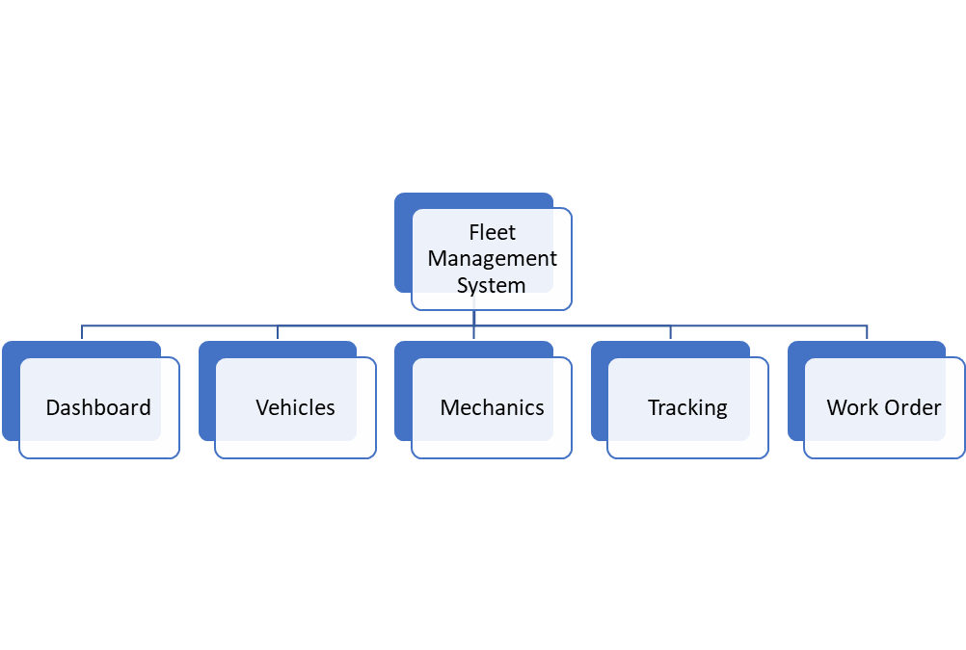

Figure 6.3. 4 : Fleet Management System Functions

Registration for new user will be available on login page. In Login Page, enter username and password which will be further authenticated and recognize their username as admin accordingly functional window will open.

**Vehicle’s Functions**: In this Function, all the vehicles are listed there. Admin has the privilege to add vehicles and view all the available vehicle. Under the Vehicles function there will be 2 options:

1. Add Vehicles
2. All Vehicles

**Add Vehicles:** In the Add Vehicles form there will be all the necessary information about the vehicles & the owners of the vehicles. Add vehicles form will have 8 fields which will be:

1. Vehicle Id
2. Vehicle Brand & Model
3. License Plate No.
4. Color
5. Owner’s Name
6. Owner’s Contact Number
7. Owner’s Email Address

**All Vehicles:** Every time the add vehicles form will be submitted all the details kept collected in a report called All Vehicles.

**Mechanics Functions:** Under the Mechanics Function there will be 2 options:

1. Add Mechanics
2. All Mechanics

**Add Mechanics:** Add Mechanics form will be used to add the mechanic’s information in the system & after that we can assign the vehicles to an active mechanics. Add Mechanics form will have 4 fields those will be:

1. Workshop Name
2. Mechanic Name
3. Mechanic Email
4. Mechanic Phone Number

**All Mechanics:** Every time the form will be submitted all the details kept collected in a report called All Mechanics.

**Tracking Functions:** Tracking Function will be used to track the real time locations of the vehicles.

**Work Orders Functions:** Under the Work Orders Function there will be 2 options:

1. Add Work Order
2. All Work Order

**Add Work Order:** Add Work Order form will be used to add the order details & the mechanic to whom the work will be assigned, and they will have a deadline by which they have to complete the work.

1. Vehicle Id
2. Date
3. Word Order Title
4. Issue Description
5. Assigned to
6. Deadline
7. Total Cost
8. Work Status (Radio Button)
   * Pending
   * Resolve

**All Work Order:** Every time the form will be submitted all the details kept collected in a report called All Work Order.

**Dashboard Functions:** The Dashboard Function will have the workshop list, the active vehicles & and all the work orders. Also right form the dashboard there will be an option to click on the resolve issues. There will be 3 reports-based data in the dashboard page which will be about:

1. Workshop List
2. Active Vehicles
3. Work Orders

6.3.5 Non-functional Requirements

➢ **Usability**

User interface will be user friendly, so user can be familiar to the system and easy to use.

➢ **Reliability**

The system will be able to meet specified objectives as well as the expectations of the customers.

➢ **Performance**

The system should provide the services in considerable time interval.

➢ **Security**

The information provider by the user should be authentic which protect the system from external attack and spamming.

6.4 Product Features

6.4.1 Input

Input design is a part of overall system design. The main objective during the input design is as given below:

* To produce a cost-effective method of input.
* To achieve the highest possible level of accuracy.
* To ensure that the input is acceptable and understood by the user.

Here I am including some input of my project.

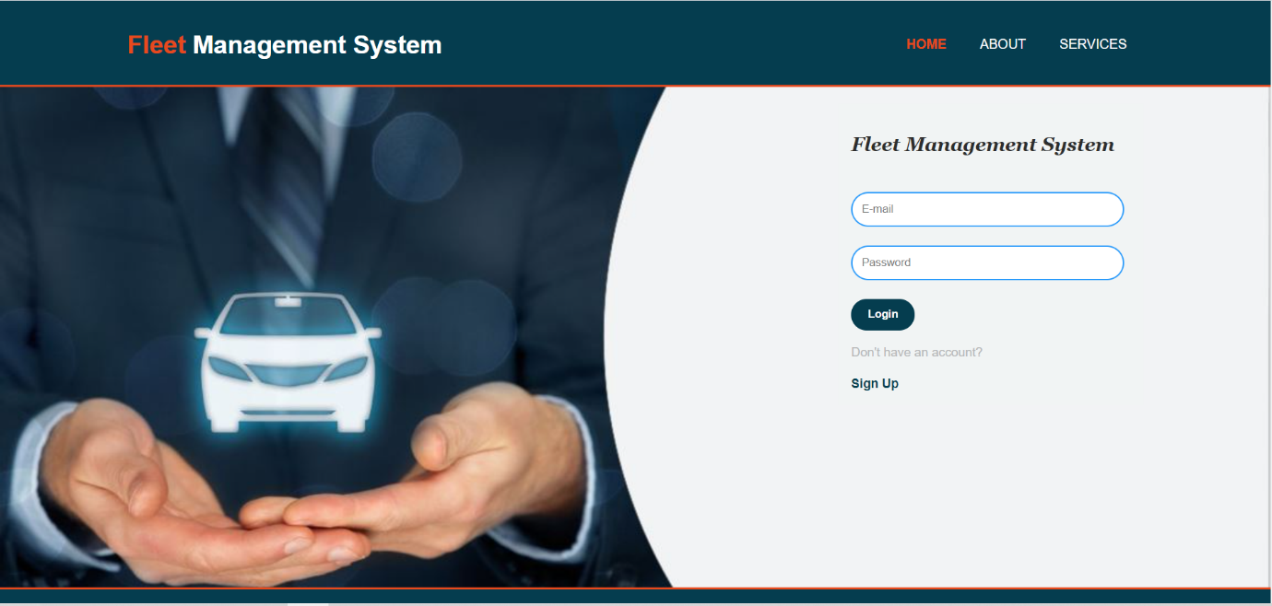

Screenshot 6.4.1. 1 : Login Page

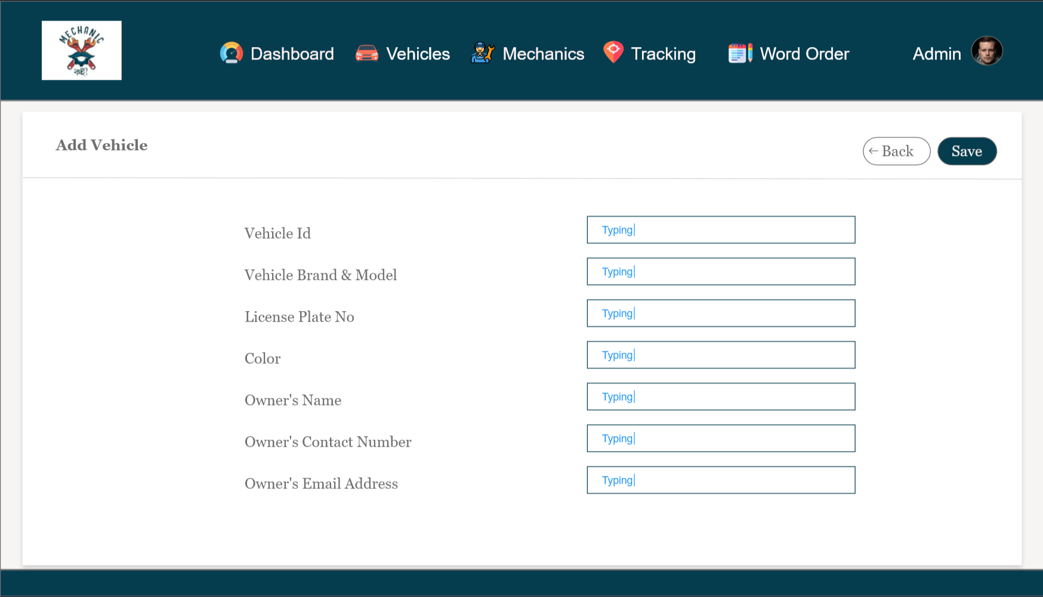

Screenshot 6.4.1. 2 : Add Vehicle Form

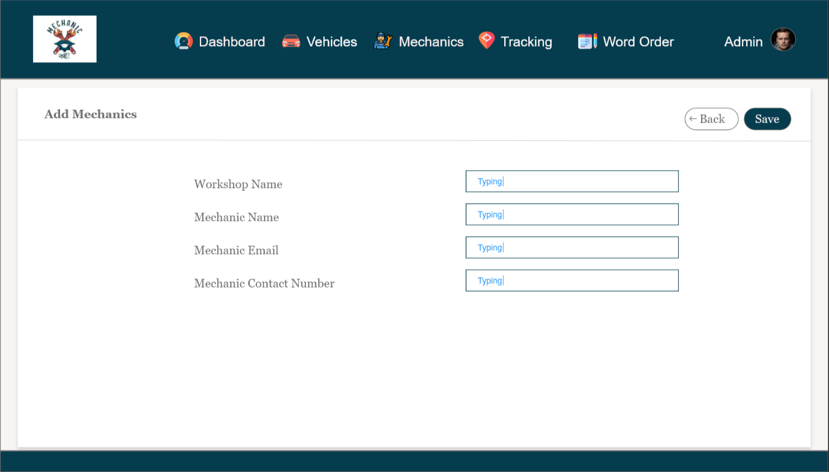

Screenshot 6.4.1. 3 : Add Mechanic Form

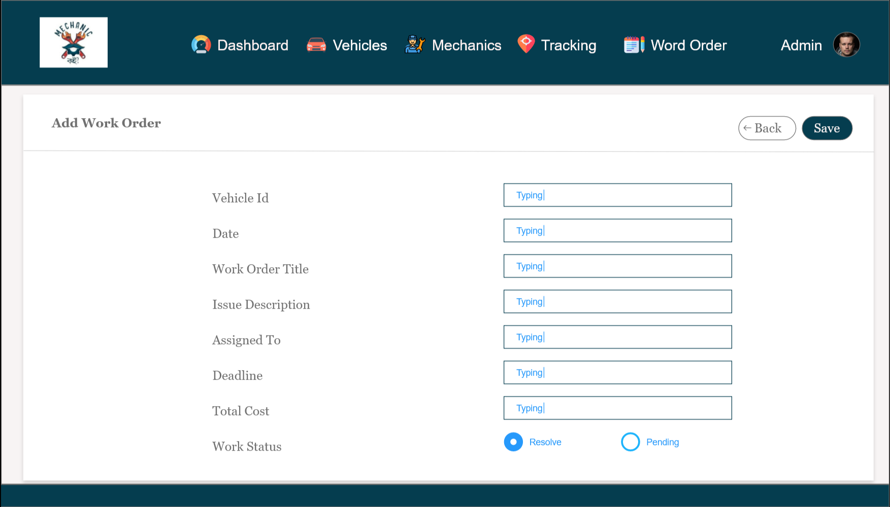

Screenshot 6.4.1. 4 : Add Work Order

6.4.2 Input Stages

A web portal, that caters to the right target audience, and fits in perfectly with your business needs, goals and vision is the first step towards building a successful business. Web development is a complex process that involves various phases from start to finish.

There are 8 phases that turn a website concept into a fully functioning web application. A good understanding and proper documentation of these phases, breakdown of tasks and resources, and allotment of roles to various teams form the road map for a smooth, optimized, and timely completion of any project. The main input stages before the information gets stored in the database media:

Data recording: The general purpose of data recording is to set in writing and assure the preservation of the data collected in the course of field or laboratory studies. The experimental design of each study determines the types of data to be collected in terms of the objectives and resources available for the study.

Data transcription: Data transcription is an important and necessary component to qualitative research. The term refers to a process by which an audio and/or video recording is interpreted or translated into words that can then be studied and coded. Accuracy and authenticity of data are the most important details while performing Data Transcription service.

Data conversion: Data conversion is the conversion of one data format into another. It is a technical process mostly done by software, although rarely hardware or human intervention is used. The sole purpose of the data conversion is to enable interoperability and to maintain all of the data with embedding as much as information as possible. Data conversion can be simple, or complex based on the environment and data formats involved. Data is handled by the operating system and different applications in different manners, so in order to use the same data for other operating systems or applications, data must be converted.

Data verification: Data verification is a process in which different types of data are checked for accuracy and inconsistencies after data migration is done. It helps to determine whether data was accurately translated when data is transferred from one source to another, is complete, and supports processes in the new system. During verification, there may be a need for a parallel run of both systems to identify areas of disparity and forestall erroneous data loss. A type of data verification is double entry data and proofreading data. Proofreading data involves someone checking the data entered against the original document. This is also time consuming and costly.

Data control: Data control is the process of governing and managing data. It is a common type of internal control designed to achieve data governance and data management objectives. Data control commands in SQL control access privileges and security issues of a database system or parts of it. These commands are closely related to the DBMS (Database Management System) and can therefore vary in different SQL implementations.

Data transmission: Data transmission refers to the process of transferring data between two or more digital devices. Data is transmitted from one device to another in analog or digital format. Basically, data transmission enables devices or components within devices to speak to each other.

Data validation: Data validation means checking the accuracy and quality of source data before using, importing, or otherwise processing data. Different types of validation can be performed depending on destination constraints or objectives. Data validation is a form of data cleansing.

Data correction: Data correction is the activity of checking data which was declared (is possibly) erroneous.

6.4.3 Output

Here I am including some output of my project.

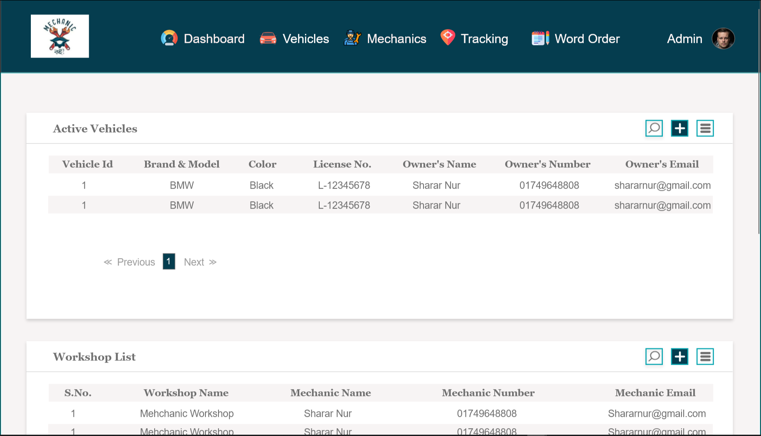

Screenshot 6.4.3. 1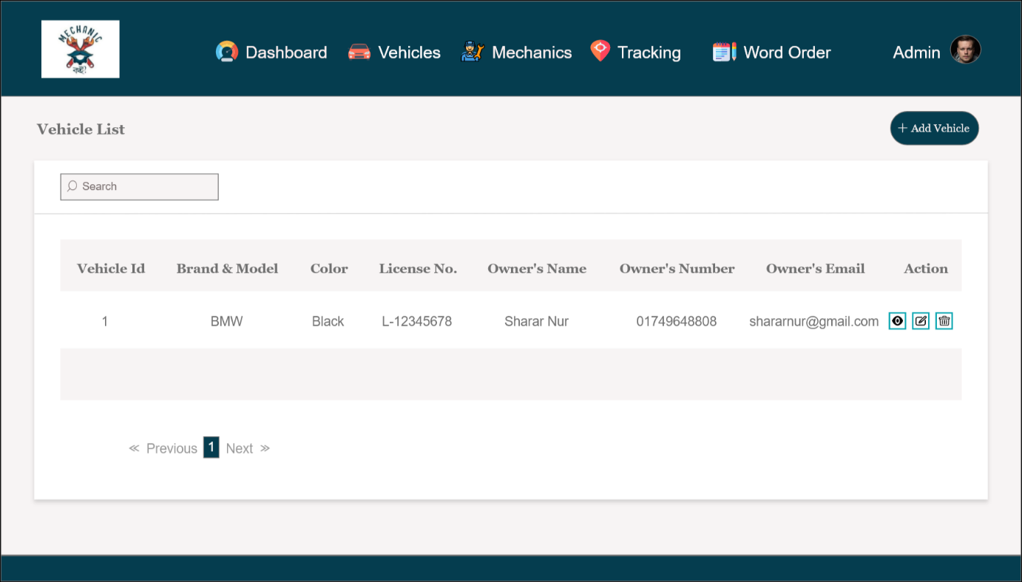 : Dashboard

Screenshot 6.4.3. 2 : All Vehicle

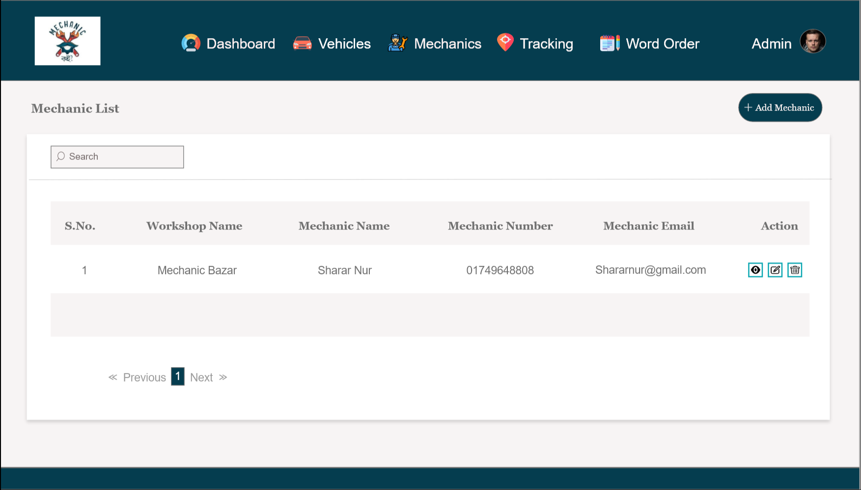

Screenshot 6.4.3. 3 : All Mechanics

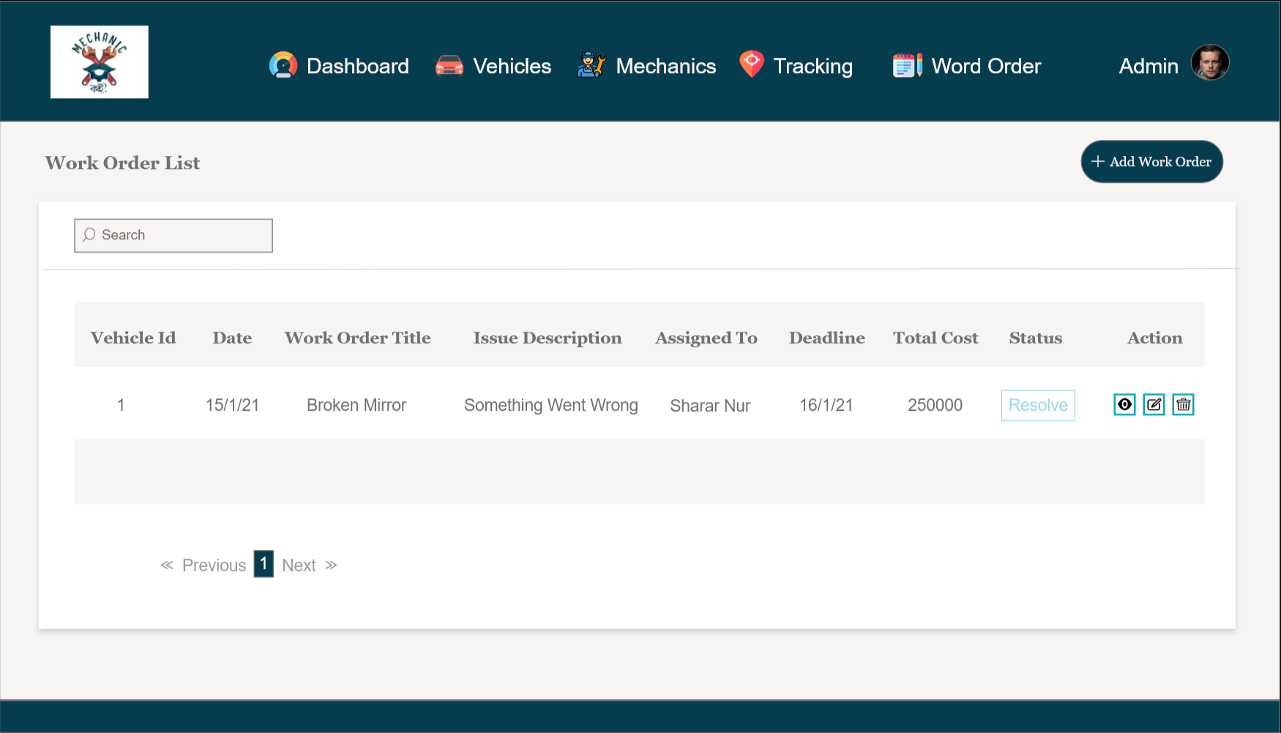

Screenshot 6.4.3. 4 : All Work Order

6.4.4 Architecture

System Architecture

We will be following a Three Tier Architecture, which is a client-server architecture. It is a multitier architecture (often referred to as n-tier architecture) which consists of three physically separated layers- presentation (client), application processing (application server), and data management (database server). The layers are independent making it easier to maintain, faster development as there is division of word (web designer does the presentation, software engineer does logic, and database admin does the data model), and component are reusable.

Figure 6.4.4. 1 : Three Tier Architecture

6.5 Implementation

Project implementation (or project execution) is the phase where visions and plans become reality. This is the logical conclusion, after evaluating, deciding, visioning, planning, applying for funds and finding the financial resources of a project. Technical implementation is one part of executing a project. For developing this fleet management system, the technical requirements are:

* Operating system
* Server
* Browser
* Xampp
* Code editor (Visual Studio)
* HTML5
* CSS3
* JavaScript
* PHP
* Bootstrap
* MySQL

6.5.1 phpMyAdmin

phpMyAdmin is a free software tool written in PHP, intended to handle the administration of MySQL over the Web. phpMyAdmin supports a wide range of operations on MySQL and MariaDB. Frequently used operations (managing databases, tables, columns, relations, indexes, users, permissions, etc.) can be performed via the user interface, while you still have the ability to directly execute any SQL statement. It is used to control administration of MySQL database.

Primary Key: name

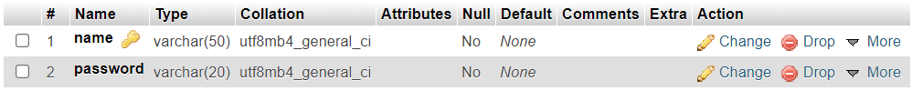

Table 6.5.1. 1 : Login

Primary Key: vehicleid

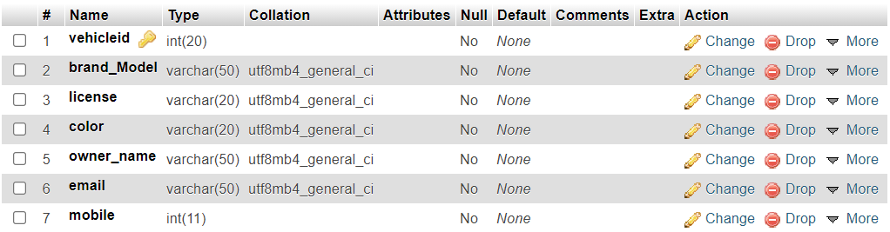

Table 6.5.1. 2 : Vehicle List

Primary Key: serial

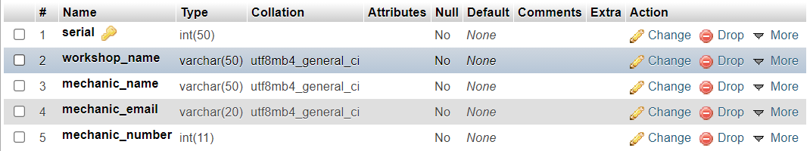

Table 6.5.1. 3 : Mechanic List

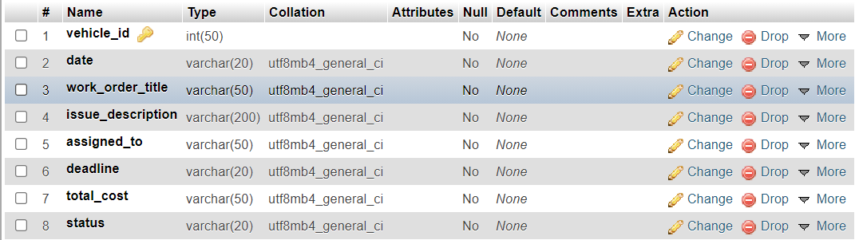Primary Key: vehicle_id

Table 6.5.1. 4 : Work Order List

Chapter 7

Results & Analysis

Here, I have given the results of tasks that I have worked on. Each task performs successfully if it meets the conditions that are provided. At the beginning we found some bugs but after several tested, we fixed it. All these tasks are tested on local hosting. Some of these tasks have some shortcomings which are not implemented yet have been mentioned above. These will be worked later on.

After the project is completed and before going live, it will be tested again, and changes will be made if required.

|  |  |  |  |  |  |  |
| --- | --- | --- | --- | --- | --- | --- |
| Task | Description | Conditions | Success rate | Error rate | Shortcomings | Working or not |
| Registration/ Sign In/  Login | Admins need to create an account and logged into it to start using the fleet management system | Admin needs to have a computer, laptop or smart phone connected to an Internet | 100 |  |  | Working |
| Add Vehicles | Admin can add a vehicle & All the vehicles list will be shown as a report in All vehicles | Admin needs to have a computer, laptop or smart phone connected to an Internet | 100 |  |  | Working |
| Add Mechanics | Admin can add a mechanics & all the mechanic list & other relevant information will be shown as a report in All Mechanics | Admin needs to have a computer, laptop or smart phone connected to an Internet | 100 |  |  | Working |
| Add Work Orders | Admin can add a work order & all the mechanic list & every time a work order is added all the details kept collected in a report called All Work Order. | User needs to have a computer, laptop or smart phone connected to an Internet. | 100 |  |  | Working |
| Dashboard | Admin can view the workshop list, the active vehicles & and all the work orders in Dashboard | Admin needs to have a computer, laptop or smart phone connected to an Internet. | 100 |  |  | Working |

Table 7. 1 : Result & Analysis

Some of the key findings that I have found after the analysis of fleet management system are:

**Improve driver safety:** Driver safety must be of paramount importance to fleet managers. A recent study concluded that speed is “at the core of the road safety problem” and that “in around 30% of the fatal accidents speed is an essential contributory factor." Because of this, driver performance and behavior are one of the keys focuses of a fleet management system.

A major benefit of fleet management software is that it produces near real-time alerts and notifications about dangerous driving habits. This is where fleet management technology can help. By keeping track of their drivers, businesses can more easily monitor, deal with and ultimately help reduce the incidences of dangerous driving.

**Lower fuel consumption:** Ever-fluctuating fuel prices make tracking and budgeting for fuel costs a challenge. Fuel consumption is about more than just KM/L though, and easy access to fuel tracking data is another benefit of a fleet management system. Using this, fleet managers can easily identify saving potentials.

Take engine idling for instance. In-depth fuel tracking data reports will separate necessary idling from excessive idling, so that fleet managers can identify and resolve problems. After pinpointing the problem, you can coach drivers on more efficient driving. According to a recent study, “just a 10% reduction in fuel costs can result in a 31% increase in profit”3, which can have a huge impact on your bottom line.

**Custom reporting helps increase efficiency and cuts costs:** Increased efficiency is one of the biggest benefits of a fleet management system. The software provides detailed, custom reports for fleet managers to turn data into actionable information. It is so much more than just knowing the location of vehicles. Share detailed reports to give team members the opportunity to understand where improvements can be made.

**Improve vehicle maintenance:** Fleet maintenance and vehicle lifecycles can often be areas that put a heavy strain on a business’s finances. Fleet management systems provide everything needed to develop a preventative maintenance schedule that works for a fleet, helping you manage maintenance costs.

Kilometers travelled, engine hours, fuel usage—just a small selection of the data points that can be used to create a preventative maintenance schedule. Fleet management system also allows managers to track vehicle downtime caused by breakdowns, jumpstarts, tows, and emergency repairs. This can help to identify potential problem areas and repeating patterns that may need addressing or adjusting in the maintenance schedule.

**Improve customer satisfaction:** Using fleet management system, fleet managers can simplify bookings and appointment reminders. Receive notifications if a technician is delayed on a job or has not yet viewed a job assigned to them. Customers can benefit from improved ETA accuracy through GPS tracking data. Plus, receive confirmation of appointments and reminders shortly beforehand.

**Improve route planning:** Fleet tracking systems help businesses plan the days, routes, and distribution of their fleet efficiently. Getting more out of the resources that they have available has the potential to save a great deal of money in the long run.

Chapter 8

Project as Engineering Problem Analysis

8.1 Sustainability of the Project/Work

We tried to make the web application as much sustainable as possible.

1. Growth of Business: This web application helps the business owner of any vehicle related company to develop their business dynamically.
2. User Friendly Interface: We have kept the webapp as simple as possible so that users do not find it difficult to use the website.

8.2 Social and Environmental Effects and Analysis

Our project with focus on social, economic, and environmental issues will gain a competitive advantage and have a credible reputation in the public eyes. This kind of focus is shown on projects’ sustainability report, as a concept that becomes important for businesses both at national and global levels.

Some of the social effects of Fleet Management System are Illustrated below:

**Improved Dispatching Allows for Additional Jobs**

When there is a better understanding of where the vehicle fleet is located, how much time they have left on their job, and more, companies can begin to introduce additional jobs and projects for new and existing vehicle drivers. This means that your company can directly increase potential profit margins as a result of more effective fleet management.

**Automate Your Fleet Reports**

Fleet management systems can deliver reports hourly, daily or weekly based on the criteria you need fulfilled. If you want to understand the habits of your vehicular fleet and make adjustments based on the analysis, a fleet management system can allow you to do that.

**Improve Vehicle Fuel Efficiency**

Fleet management systems allow a fleet manager to analyze behavior of drivers as well as view idle times of each vehicle. Some systems may allow for the tracking of receipts used for refueling, which can provide further information about the vehicle and fueling habits of a driver as well as driving conditions. When more information is provided about refueling, companies can make more informed decisions and make changes that are based on data as opposed to theory and guesses.

**Improve Safety for the Fleet**

Your fleet management systems can provide an opportunity for better safety habits. With software, you will be able to analyze patterns, behaviors, and habits of individual drivers. This information will allow you to make more informed decisions about how to improve driver habits, bring dangerous driving behavior to their awareness, and more.

**Improved Insurance Benefits**

Introducing a fleet management system into your daily business operations can provide other financial bonuses through insurance. An insurance company may be willing to provide discounts or other financial incentives for businesses that utilize a fleet management system as they know that they have the opportunity to improve safety on the roads and reduce accidents. You can ask your insurance company if they support discounts based on the utilization of fleet management systems, implemented safety policies and other active monitoring initiatives.

**Improves Customer Service and Satisfaction**

A fleet management system improves delivery times and reduces wait times for customers. You will be able to provide a more efficient and effective service to all of your clients, regardless of the operation you run. When customers are getting high quality service, they will be more likely to stay loyal to your company and return for additional service.

If you use vehicles as part of your business or daily operations, a fleet management system can be a great way to improve effectiveness of your business. From increasing fuel efficiency to reducing accidents to more efficient logistics, a fleet management system is key to any company with a vehicular fleet [8].

**Environmental effects**: Effective fleet management system can reduce fuel consumption and associated emissions. Alternative fueled vehicles (propane, natural gas, etc.) may also be viable options that offer reduced environmental impact over traditional gasoline vehicles. Safety and infection control for employees through following AAMI standards for infection control, DOT and OSMA standards for transportation of goods.

8.3 Addressing Ethics and Ethical Issues

Ethics are a set of standards governing the conduct of members of a profession. Ethics establish basic values for responsible actions and practices within a professional community. Although there may be no punishment for violating ethical standards, some practices (such as spamming and sending viruses) are being written or will be written into law [9].

The generally agreed-upon ethical standards for Web professionals have developed from years of experience, and many have been inherited from other professions. Examples of ethical behavior for Web professionals include the following:

* Do not send unsolicited bulk e-mail, or spam.
* Do not buy domain names that you do not intend to use (a practice also known as domain squatting or cyber-squatting).
* Do not knowingly spread malicious program code such as viruses or worms.
* Do not pass along chain e-mail messages, especially those that imply threats.
* Be honest with your customers, and do not overcharge for technical services that they may not understand.

Chapter 9

Lesson Learned

9.1 Problems Faced During this Period

Web development has been a fast-growing industry over the past decade. In most cases, web developers work as employees or contractors for creating web applications for organizations. Several techniques and skills, such as programming and interface design, are required. Web developers are also responsible for determining a website’s content together with implementing other tools such as links. However, many have not put into consideration some of the challenges students face while learning and putting into practice web development technologies. Different students may have different web development learning experiences. Also, most students often wonder about what the major constituents of an outstanding modern website are. Some of the problems that I have faced during my internship period are:

**Presence of broken links**

These non-functioning links impact the overall quality of the website. First, it frustrates the users. Second, it frustrates Google, leading for the tech giant to assume that you are not practicing diligence to update your contents at the very least. The number of error pages on your website is a clear indication that your site is of low-quality.

**Slow site loading times**

One of the reasons is the slow server wherein your site could be hosted using a shared account. This means your website is sharing the server with hundreds to thousands of other websites. You can check with your hosting company to know if the site is hosted on a dedicated server. If not, you may request for this service, but it may entail additional cost.

**Non-specific page titles**

A website includes several HTML elements although the most important are the title tags. The title tag sums up the entire content of a website or web page to Google and other major search engines. Still, some websites cannot get them right somehow that even when the owners search for their own domain, the website appears as is with the same title throughout the website. In fact, there are websites that appear in Google using the filler texts lorem ipsum. We have seen many of them. The search engine looks for duplicate title tags to gauge the uniqueness of the site, losing out on traffic due to such duplicates.

**Duplicate homepages**

Not all website owners are aware of this, but the problem occurs when the server returns two versions of the homepage – the yoursite.com/ and the yoursite.com/index.html. The major search engines especially Google may regard this as duplicate content and thereby, penalize the website by de-indexing it.

**Canonicalization problem**

When a website is not properly canonicalized, Google may also assume that it has a duplicate. Canonicalization refers to an individual page that can be loaded through multiple URLs, the most common of which is the URL with www and without www. This means that a website is configured at www.yoursite.com but not at yoursite.com. When multiple URLs exist, Google will choose the best URL to represent the content based on the query.

**Email address exposure**

Some business opts to publish their email addresses on the site itself. There is nothing completely wrong about this if you are not very concerned with receiving spam emails from entities that use web crawlers to scrape email addresses. Your web developer should have advised you to remove it and offer an alternative.

**W3C markup validation non-compliance**

An international association which develops web standards, the Word Wide Web Consortium (W3C) offers its own markup validation service. Such a service ensures that the website is compliant to the standards. Sadly, not all websites are W3C compliant. While W3C compliance may not be considered as a ranking signal or factor itself, poor coding can possibly harm other ranking factors. Thus, compliance is necessary.

9.2 Solution of those Problems

**Presence of broken links**

I have solved this problem running monthly checkups on the site to identify if there are any broken links and remove them one by one. Good thing there are several free tools online that you can use.

**Slow site loading times**

Solve the problem checking the speed score in Google using its PageSpeed Insight tool. Just key in your domain and click Analyze. The tool analyzes the contents of the site and determines which elements are rendering it slower. It generates suggestions to make your website even faster that it is now.

**Non-specific page titles**

For check, what I did a name search as “site:yourdomain.com.” Head on to Google Search Console (formerly Google Webmaster Tools) to analyze my website. The tool also provides information on other HTML errors such as missing title tags, duplicate meta descriptions, missing descriptions, etc.

**Duplicate homepages**

Fixing it is simple, only it requires a technical to do it. The .htaccess file must be edited.

The following code must be added to the server.

<RewriteEngine on | RewriteCond %{THE_REQUEST} ^[A-Z]{3,9}\ /.*index\.html\HTTP/# | RewriteRule^(.*)index\.html$ http://%{HTTP_HOST}/$1 [R=301,L]>

Any editing mistake may ruin the entire website with a 500 internal server error. The index and html must be replaced with the homepage’s actual file name and extension.

**Canonicalization problem**

Most importantly, the website must use a uniform format; all pages with www if it uses www and all pages without www if it uses no www. You cannot mix www pages with non-www pages. If you currently have these pages, make sure that the non-www pages redirect to www and vice versa. Use 301 redirection to ensure that the homepage is in just one URL. Also, help

Google bots index just one version by adding <link rel=”canonical” href=”http://www.yoursite.com/”> to the page you want them to index.

**Email address exposure**

I have used encryption techniques when publishing business email add to minimize the possibility of or prevent spamming altogether.

**W3C markup validation non-compliance**

I have solved this using subjecting the site to thorough tests to determine its overall health.

Chapter 10

Future Work & Conclusion

10.1 Future Works

Advancements in automotive technology will see future vehicles with integrated technology to directly manage fuel purchases and capture telematics data to manage driver behavior and proactive maintenance scheduling. The inclination towards cloud computing will enable fleet solution providers to offer higher degrees of data and system integration. These new technology capabilities will result in highly customizable solutions for fleet managers.

* Mobile Application could be developed for the system to reach out to more users.
* Could be extended to vehicle tracking system in real time & can have filters to select different vehicles.
* Integrated technology to Free Vehicles from Policy Constraints.
* Cloud computing to accelerate fleet decision-making.
* The UI could be improved to make the application look more elegant and richer.
* Add the functionality to store the trips made by each vehicle on a particular day.
* Perform analysis on the old data and generate reports, which could be useful for the business.

10.2 Conclusion

The internship has been a very fruitful and worthy experience for me. I was able to work, hands-on, in an industry that I had no prior knowledge about. The process of transforming the rich theoretical knowledge with the practical knowledge of the industry has dawned on me and driven to seek excellence in the craft of Web Development.

Interns do not usually get to work on live projects and contribute to the workflow of an ongoing project in the office. But the people at Mechanic koi Pvt. Ltd, felt that I was worth giving a chance to and tasked me with such projects that would help me grow in every aspect of my career. Being the youngest there and the least experienced of the bunch, I got a plethora of advice from the people of the offices. I also learned the tools and techniques that were utilized by industry hardened software developers and engineers alike.

On top of that I was taught etiquettes of the corporate life and how to maintain proper rapport with my co-workers. These are the skills that cannot be learned using books and must be applied to assure proper implementation. It was a blessing for me to be in the presence of such good people who were willing to help me at each part of my journey through the internship.

In the end, I would like to thank both my internal and external supervisors whose guidance and motivations have persuaded me to strive for the success in this project and for the endless projects to come in my way in the future.

Bibliography

|  |  |
| --- | --- |
| [1] | J. a. P. Jung, "Design and Modeling of Real-time Shared-Taxi Dispatch Algorithms," California, January 2013. |
| [2] | A. J. B. D. R. L. Anurag Mandle, "Taxi Automation Using Real TimeAdaptive Scheduling," *International Journal on Recent and Innovation Trends in Computing and Communication ,* vol. 2, no. 3, pp. 592 - 594, Mar 31, 2014. |
| [3] | J. S. J. K.G., "Enabling Location Privacy in Pervasive Computing by Fragmenting Location Information of Users," Cochin, August 2012. |
| [4] | M. M. K. Suhas Holla, "Android Based Mobile Application Development And Its Security," *International Journal of Computer Trends and Technology (IJCTT),* vol. 3, no. 3, pp. 486-490, 2012. |
| [5] | A. Challa, "Fleet Management System," Abhishek Challa, Manhattan, 2016. |
| [6] | M. K. V. R. C. S. k. Kumar. k, "Fleet Management System," Kumar. k, Mohan Kumar V, Ramanathan. C, Sathish. k, Chennai, April, 2016. |
| [7] | A. D. Moudgil, "Vehicle Management System," Aman Deepak Moudgil, Solan, 2016. |
| [8] | K. D. M. A. R. K. K. S. A. M. A. G. Md. Mokabbir Ullah Faisal, "Documentation of Dhaka vehicle system," Md. Mokabbir Ullah Faisal, Koushik Das, Md. Ashikur Rahman Khan, Khan Shohag Ali, Md. Abdul Gaffar, Dhaka, April,2017. |
| [9] | H. Saghaei, "Design and Implementation of a Fleet Management System Using Novel GPS/GLONASS Tracker and Web-Based Software," Shahrekord, 2016. |